**PURBANCHAL UNIVERSITY**



**Faculty of Science and Technology**

Biratnagar, Nepal



**KIST College of Information and Technology**

Kamalpokhari, Kathmandu

**4th SEMESTER PROJECT**

**ON**

**“Library Management System”**

In the partial fulfillment for the requirement of the 4th Semester Project - IV (**Subject code – BIT279CO**) in the completion of Bachelor of Information Technology (BIT) degree at KIST college of Information Technology, under Purbanchal University.

|  |  |  |
| --- | --- | --- |
| **Submitted By** |  | **Submitted To** |
| Manoram Subedi | 344952 | Purbanchal University |
| Saroj Adhikari | 344969 |  |
| Kshitiz GC | 344951 |  |
| Md Samsad Ali | 344954 |  |

DATE: 06/08/2021

**ACKNOWLEDGEMENT**

We take this opportunity to express our gratitude and unfathomable regards to the Information Technology (IT) department for this commendable guidance, monitoring and constant encouragement throughout the course of this project. The help and guidance given by shall carry us the long way, in the journey in which we are about to commence.

We also take this opportunity to express a deep sense of gratefulness to our college’s IT department coordinator as well as our project teacher Mr. Mohammad Faijan for his amiable support, valuable information and guidance which helped us in completing this task throughout its various stages. We are indebted to all members of KIST College, for the valuable support and suggestion provided by them using their specific fields’ knowledge. We are grateful for their cooperation during the period of our project.

We would also like to express our gratefulness towards Purbanchal University for designing such a wonderful course structure. It will help us to get more knowledge in the field of Information Technology & help us to have a bright future in the field of technology.

At the end we would like to express our sincere thanks to all our friends and families who helped us directly or indirectly during this project work.

Thank You.

**STUDENT’S DECLARATION**

We hereby declare that the project report entitled **“Library Management System”** is a result of our own work. If we are found guilty of copying any other report or published information and showing as our original work, we understand that we shall be liable and punishable by Purbanchal University.

We further certify that this Project submitted in partial fulfillment of the requirement for the award of Bachelor in Information Technology (BIT) of the Purbanchal University is our original work and has not been submitted for award of any other degree or other similar title or prize.

|  |  |  |  |
| --- | --- | --- | --- |
| **S.N.** | **Name** | **Registration No.** | **Symbol No.** |
| **1** | Manoram Subedi |  | 344952 |
| **2** | Saroj Adhikari |  | 344969 |
| **3** | Kshitiz GC |  | 344951 |
| **4** | Md Samsad Ali |  | 344954 |

**EXAMINER’S CERTIFICATION**

**The Project Report**

**On**

**“Library Management System”**

**Developed By:**

**Manoram Subedi**

**Saroj Adhikari**

**Kshitiz GC**

**Md Samsad Ali**

is approved and is acceptable in quality and form.

…………………………………. ………………..…………………

**Internal Examiner External Examiner**

Name: Name:

Designation: Designation:

**TO WHOM IT MAY CONCERN**

This is to certify that **Mr. Manoram Subedi, Mr. Saroj Adhikari, Mr. Kshitiz GC** and **Mr. Md Samsad Ali** of Bachelor in Information Technology (**BIT**) has studied as per the curriculum of BIT 4th semester and completed the project entitled **“Library Management System”.**

This project is the original work of Mr. Manoram Subedi, Mr. Saroj Adhikari, Mr. Kshitiz GC and Mr. Md Samsad Ali and was carried out under the supervision as per guidelines provided by Purbanchal University and certified as per the students declaration that project **“Library Management System”** has not been presented anywhere as a part of any other academic work.

**The details of the students are as follows:**

|  |  |  |  |
| --- | --- | --- | --- |
| **S.N.** | **Name** | **Registration No.** | **Symbol No.** |
| **1** | Manoram Subedi |  | 344952 |
| **2** | Saroj Adhikari |  | 344969 |
| **3** | Kshitiz GC |  | 344951 |
| **4** | Md Samsad Ali |  | 344954 |

**Course Semester:** **-** 4th Semester

**Subject:** **-** Project-IV

**Subject code:** **-** BIT279CO

……………………………………..

**Mr. Mohammad Faijan**

**Project Instructor, BIT**

**KIST College of Information Technology**

Table of Content

1. Abstract of the project……………………………………………………………………………………...7
2. Introduction about project……………………………………………………………………………….7
3. Objective of the project…………………………………………………………………………………….8
4. Problems with the existing system……………………………………………………………………8
5. Advantages of the proposed system………………………………………………………………….9
6. Programming Language and Framework Used………………………………………….............9
7. Integrated Development Environment & Database…………………………………………..11
8. Other Technologies used………………………………………………………………………………..11
9. System Requirement…………………………………………………………………………...…………12
10. Module Description…………………………………………………………………………………..13
11. Database Table Structure…………………………………………………………………………..14
12. Use Case Diagram……………………………………………………………………………………...16
13. Data Flow Diagram……………………………………………………………………………………18
14. Screenshots…………………………………………………………………………………………...….20
15. Limitations……………………………………………………………………………………………….24
16. Conclusion………………………………………………………………………………………………..24
17. Bibliography……………………………………………………………………………………………..24

Abstract of the project

Library Management System is .NET framework based web application. This is user friendly software which is aimed to be used by the Librarian.

A librarian requires maintaining a database of new books and the books that are borrowed by users along with their due dates. This system completely automates all your library's activities

This system includes the features of database (Microsoft SQL Server) which allows the user to add, delete, modify and search required record. The main purpose or goal behind the development of this system is to enable the user to borrow in easy and efficient way. This system has features of Books information, Borrowers details, borrows inventory, librarian information, student details etc.

Introduction

The library management system is all about organizing, managing the library, and library-oriented tasks. It also involves maintaining the database of entering new books and record of books that have been retrieved or issued, with their respective dates.

The main aim of this project is to provide an easy to handle and automated library management system. This project also provides features and an interface for maintaining librarian’s records, student’s history of issues, and fines. The owner can easily update, delete and insert data in the database with this project.

Objective of the project

The prime objectives of Library Management System are listed below:

* To manage the details of Address, Member, Issues, Books, Students, Category.
* To manage all the information about Address, Librarian, Student, Member, Books.
* The purpose of the project is to build an application program to reduce the manual work for managing the Address, Member, Book, Student
* It track all the details about issues, return, Book, Address, Librarian, Student
* To maintain the records.
* To reduce time
* To store large amount of data in the database which will reduce clumsiness.
* To reduce the paper work by computerizing the data entry procedure.
* To get the information about student, librarian, stock, borrower etc. in a quick manner.
* To decrease manual labor and manual error.

Problems with the Existing System

* Manual system faces a lot of inefficiencies.
* Hinders smooth flow of work.
* Lack of security of data.
* Although more manpower, but less efficiency.
* Time consuming.
* Consume large volume of paper work.
* Needs manual calculations which are prone to errors.
* Poor communication may lead to serious inadvertent errors.

Advantages of the proposed system

* Reduced processing cost
* Error detection
* Easy Updation of product details
* Reduction of use of paper
* Reduction in man power
* Faster response time

Programming Language and Framework Used

**C#**

C# is a general-purpose, modern and object-oriented programming language pronounced as “C sharp”. It was developed by Microsoft led by Anders Hejlsberg and his team within the .Net initiative and was approved by the European Computer Manufacturers Association (ECMA) and International Standards Organization (ISO). C# is among the languages for Common Language Infrastructure and the current version of C# is version 7.2. C# is a lot similar to Java syntactically and is easy for the users who have knowledge of C, C++ or Java.

C# is one of the popular and demanding languages because it is easy to start, widely used for developing desktop application, web application and is popular in game development also.

ASP.NET MVC is basically a web development framework from Microsoft, which combines the features of MVC (Model-View-Controller) architecture, the most up-to-date ideas and techniques from Agile development, and the best parts of the existing ASP.NET platform.

**ASP.NET MVC**

ASP.NET MVC is not something, which is built from ground zero. It is a complete alternative to traditional ASP.NET Web Forms. It is built on the top of ASP.NET, so developers enjoy almost all the ASP.NET features while building the MVC application.

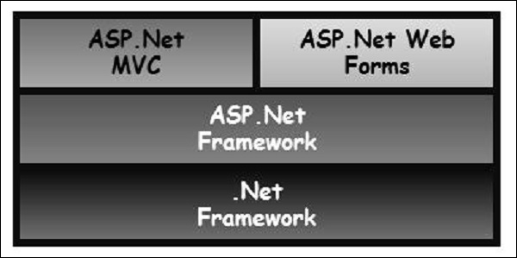

**Why ASP.NET MVC?**

Microsoft decided to create their own MVC framework for building web applications. The MVC framework simply builds on top of ASP.NET. When you are building a web application with ASP.NET MVC, there will be no illusions of state, there will not be such a thing as a page load and no page life cycle at all, etc.

Another design goal for ASP.NET MVC was to be extensible throughout all aspects of the framework. So when we talk about views, views have to be rendered by a particular type of view engine. The default view engine is still something that can take an ASPX file. But if you don't like using ASPX files, you can use something else and plug in your own view engine.

There is a component inside the MVC framework that will instantiate your controllers. You might not like the way that the MVC framework instantiates your controller, you might want to handle that job yourself. So, there are lots of places in MVC where you can inject your own custom logic to handle tasks.

The whole idea behind using the Model View Controller design pattern is that you maintain a separation of concerns. Your controller is no longer encumbered with a lot of ties to the ASP.NET runtime or ties to the ASPX page, which is very hard to test. You now just have a class with regular methods on it that you can invoke in unit tests to find out if that controller is going to behave correctly.

Integrated Development Environment (IDE) & Server

**Visual Studio**

IDE is a term commonly used in the programming world to describe the interface and environment that we use to create our applications. It is called integrated because it allows virtually accessibility of the entire development tool that we need for one screen called an interface. The IDE is also commonly referred to as the design environment, or the program. Integrated development is one in which we can develop, run, text and debug applications.

Visual Studio is an Integrated Development Environment (IDE) developed by Microsoft to develop GUI (Graphical User Interface), console, Web applications, web apps, mobile apps, cloud, and web services, etc. With the help of this IDE, you can create managed code as well as native code. It uses the various platforms of Microsoft software development software like Windows store, Microsoft Silverlight, and Windows API, etc. It is not a language-specific IDE as you can use this to write code in C#, C++, VB (Visual Basic), Python, JavaScript, and many more languages. It provides support for 36 different programming languages. It is available for Windows as well as for macOS.

There are 3 editions of Microsoft Visual Studio as follows:

1. Community

2. Professional

3. Enterprise

This project has used community edition of Microsoft Visual Studio.

**Community** edition is a **free** version which is announced in 2014. *All other editions are paid*. This contains the features similar to Professional edition. Using this edition, any individual developer can develop their own free or paid apps like *.Net applications*, Web applications and many more. In an enterprise organization, this edition has some limitations.

**Microsoft SQL Server**

Microsoft SQL Server is a relational database management system (RDBMS) that supports a wide variety of transaction processing, business intelligence and analytics applications in corporate IT environments. Microsoft SQL Server is one of the three market-leading database technologies, along with Oracle Database and IBM's DB2.

Like other RDBMS software, Microsoft SQL Server is built on top of SQL, a standardized programming language that database administrators (DBAs) and other IT professionals use to manage databases and query the data they contain. SQL Server is tied to Transact-SQL (T-SQL), an implementation of SQL from Microsoft that adds a set of proprietary programming extensions to the standard language.

SQL Server Management Studio (SSMS) is the main interface tool for SQL Server, and it supports both 32-bit and 64-bit environments.

Other Technologies Used

HTML: Page layout has been designed in HTML

CSS: CSS framework i.e. Bootstrap is used for all the designing part

JavaScript/JQuery: All the interactive features has been developed by JQuery and JavaScript

System Requirement

**Supported Operating Systems**

Visual Studio 2019 will install and run on the following operating systems (64 bit recommended; ARM is not supported):

Windows 10 version 1703 or higher: Home, Professional, Education, and Enterprise (LTSC and S are not supported)

Windows Server 2019: Standard and Datacenter

Windows Server 2016: Standard and Datacenter

Windows 8.1 (with Update 2919355): Core, Professional, and Enterprise

Windows Server 2012 R2 (with Update 2919355): Essentials, Standard, Datacenter

Windows 7 SP1 (with latest Windows Updates): Home Premium, Professional, Enterprise, Ultimate

**Hardware**

1.8 GHz or faster processor. Quad-core or better recommended

2 GB of RAM; 8 GB of RAM recommended (2.5 GB minimum if running on a virtual machine)

Hard disk space: Minimum of 800MB up to 210 GB of available space, depending on features installed; typical installations require 20-50 GB of free space.

Hard disk speed: to improve performance, install Windows and Visual Studio on a solid state drive (SSD).

Video card that supports a minimum display resolution of 720p (1280 by 720); Visual Studio will work best at a resolution of WXGA (1366 by 768) or higher.

Module Description

1. **Home Page**

This is the initial form displayed for the Admin purpose.

1. **Book Module**

The main objective of this module is to provide the functionality related to supplier. It tracks all the information and details of the supplier. CRUD operation can be performed with the supplier information.

1. **Category Module**

The main objective for developing this module is to manage the Book Category. CRUD operation can be performed with the Category information

1. **Publisher Module**

The main objective of this module is to provide the functionality related to Publisher. It tracks all the information and details of the publisher. CRUD operation can be performed with the Publisher information.

1. **Member Module**

The main objective of this module is to provide the functionality related to Member. It tracks all the information and details of the Member. CRUD operation can be performed with the Member information.

1. **Issue Book Module**

To help the user get required books issued.

1. **Return Book Module**

To return the book before the last date without fine, or after the specified time duration with a late fine.

Table Structure

**Category Table**

|  |  |  |
| --- | --- | --- |
| **Column Name** | **Null** | **Data Type** |
| cat_id (Primary Key) | Not null | int |
| category_name | Not null | nvarchar(50) |
| status | Not null | nvarchar(50) |

**Author Table**

|  |  |  |
| --- | --- | --- |
| **Column Name** | **Null** | **Data Type** |
| auth_id (Primary Key) | Not null | int |
| author_name | Not null | nvarchar(50) |
| address | Not null | Nvarchar(50) |
| phone | Null | bigint |

**Publisher Table**

|  |  |  |
| --- | --- | --- |
| **Column Name** | **Null** | **Data Type** |
| pub_id (Primary Key) | Not null | int |
| publisher_name | Not null | nvarchar(50) |
| address | Not null | Nvarchar(50) |
| phone | Null | bigint |

**Member Table**

|  |  |  |
| --- | --- | --- |
| **Column Name** | **Null** | **Data Type** |
| mem_id (Primary Key) | Not null | int |
| member_name | Not null | nvarchar(50) |
| address | Not null | Nvarchar(50) |
| phone | Null | bigint |

**Book Table**

|  |  |  |
| --- | --- | --- |
| **Column Name** | **Null** | **Data Type** |
| book_id (Primary Key) | Not null | int |
| book_name | Not null | nvarchar(50) |
| cat_id | Not null | int |
| pub_id | Not null | Int |
| contents | Not null | nvarchar(50) |
| pages | Not null | int |
| edition | Not null | nvarchar(50) |

**Issue Book Table**

|  |  |  |
| --- | --- | --- |
| **Column Name** | **Null** | **Data Type** |
| id (Primary Key) | Not null | int |
| mem_id | Not null | nvarchar(50) |
| book_id | Not null | nvarchar(50) |
| issuedate | Not null | date |
| returndate | Not null | date |

**Return Book Table**

|  |  |  |
| --- | --- | --- |
| **Column Name** | **Null** | **Data Type** |
| id (Primary Key) | Not null | int |
| mem_id | Not null | int |
| returndate | Not null | date |
| dayselap | Not null | date |
| fine | Not null | float |

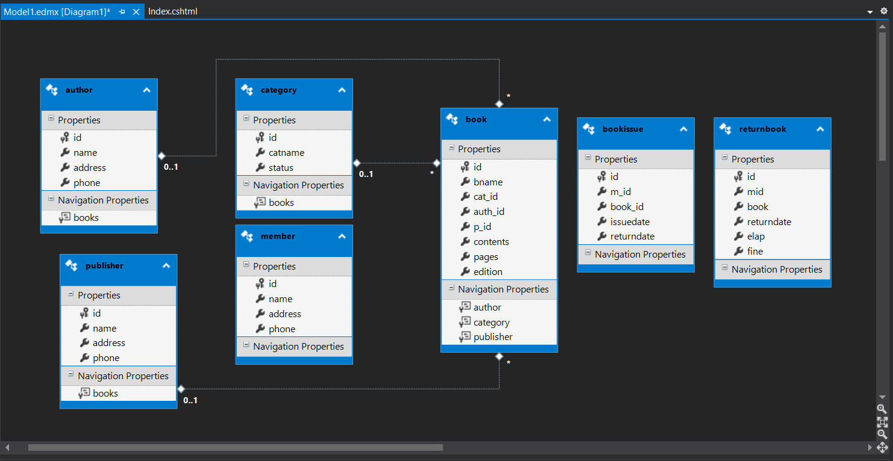Entity-Relationship Diagram

User Case Diagram

A use case diagram at its simplest is a representation of a user's interaction with the system that shows the relationship between the user and the different use cases in which the user is involved. The purpose of a use case diagram in UML is to demonstrate the different ways that a user might interact with a system.

Add Category

Return Book

Issue Book

Add Book

Add Author

Add Publisher

Add Member

Data Flow Diagram

DFD is the abbreviation for Data Flow Diagram. The flow of data of a system or a process is represented by DFD. It also gives insight into the inputs and outputs of each entity and the process itself. DFD does not have control flow and no loops or decision rules are present. Specific operations depending on the type of data can be explained by a flowchart. Data Flow Diagram can be represented in several ways. The DFD belongs to structured-analysis modeling tools. The DFD of “Grocery Store Management System” is given below:

Category Management

Author Management

Publisher Management

Book Issue Management

Book Management

Member Management

Book return Management

Category Management

Author Management

Publisher Management

Book Issue Management

Book Management

Member Management

Book return Management

Manage Category Info

Store and manage author

Store and manage publisher

Generate Book Issue

Generate Book report

Store and manage Member

Generate Book return

Screenshots

1. **Home**

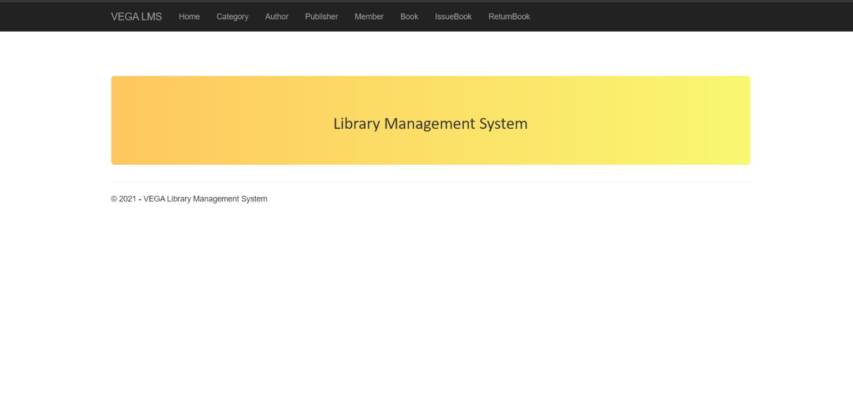

1. **Category**

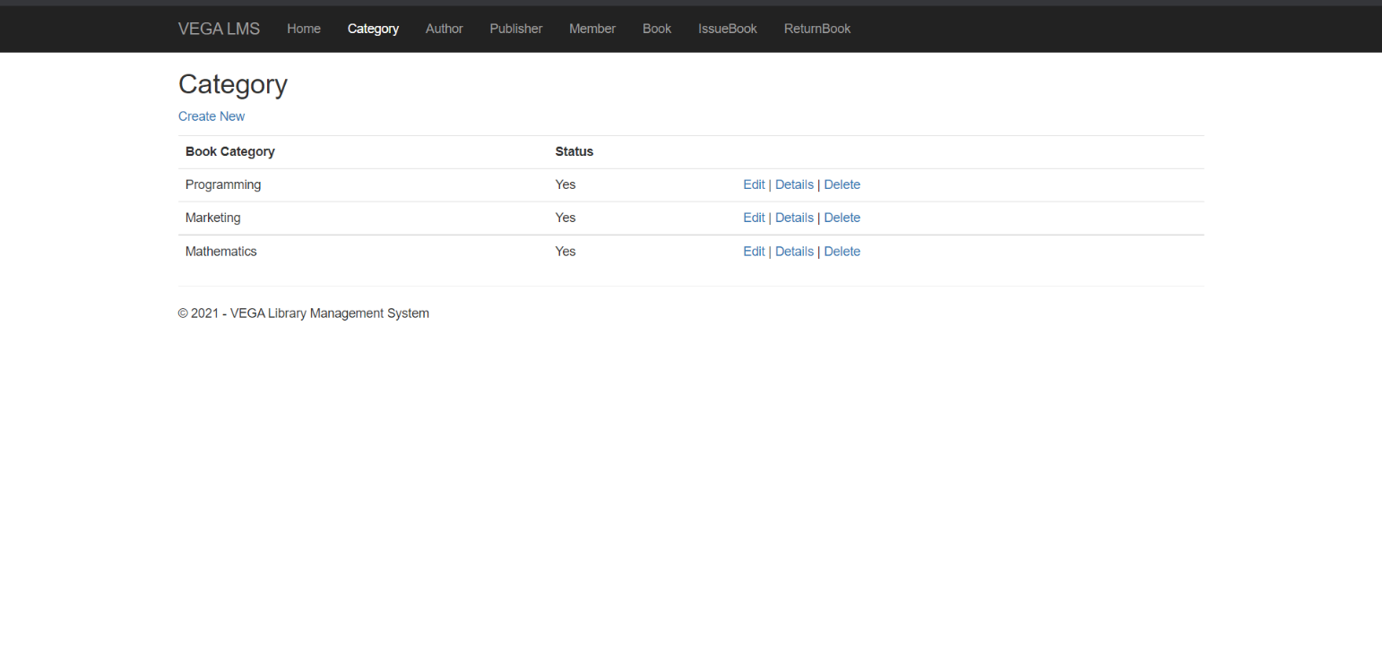

1. **Author**

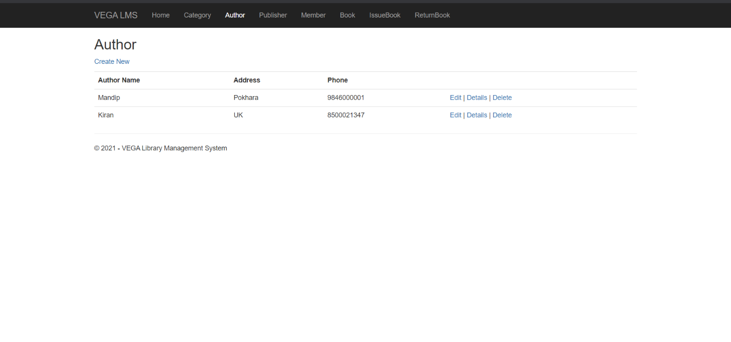

1. **Publisher**

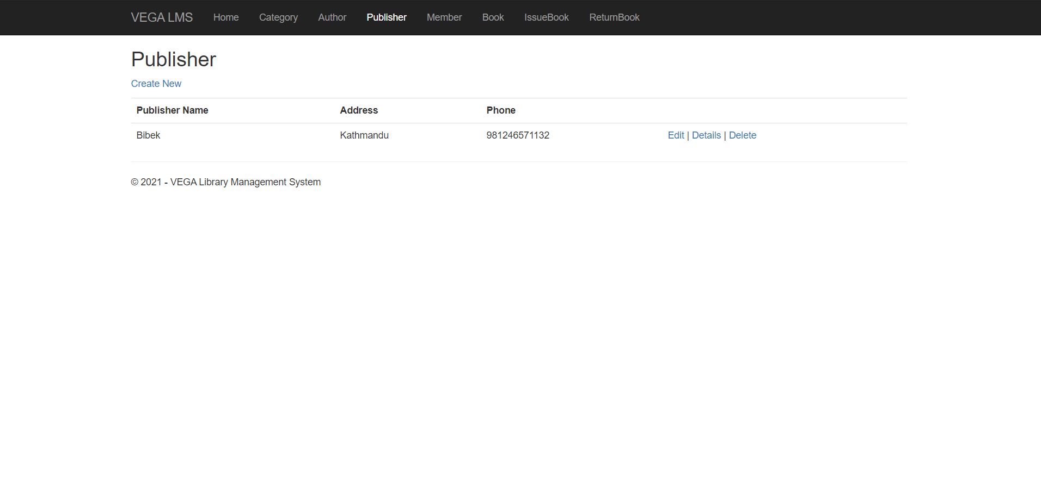

1. **Member**

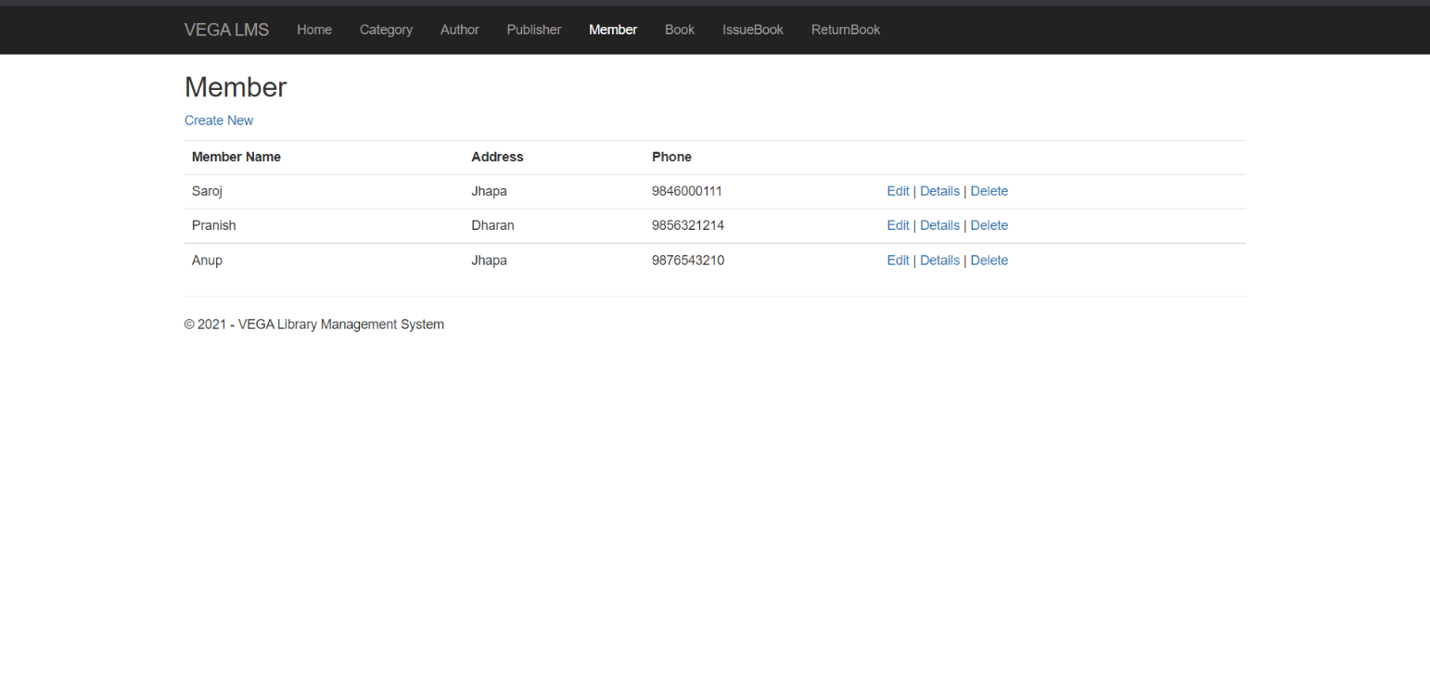

1. **Book**

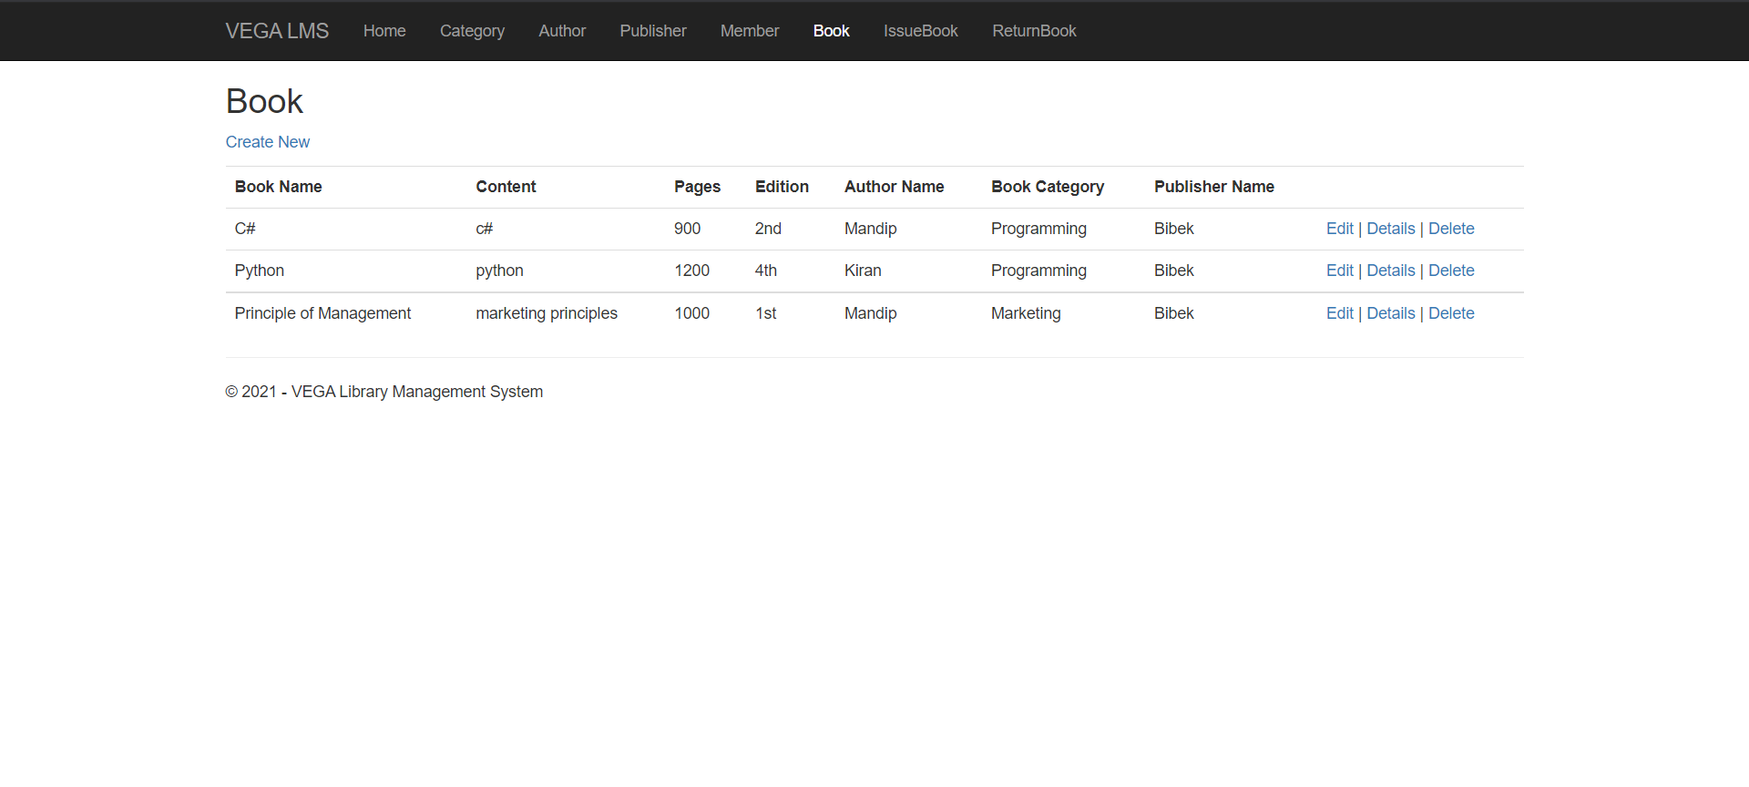

1. **Issue Book**

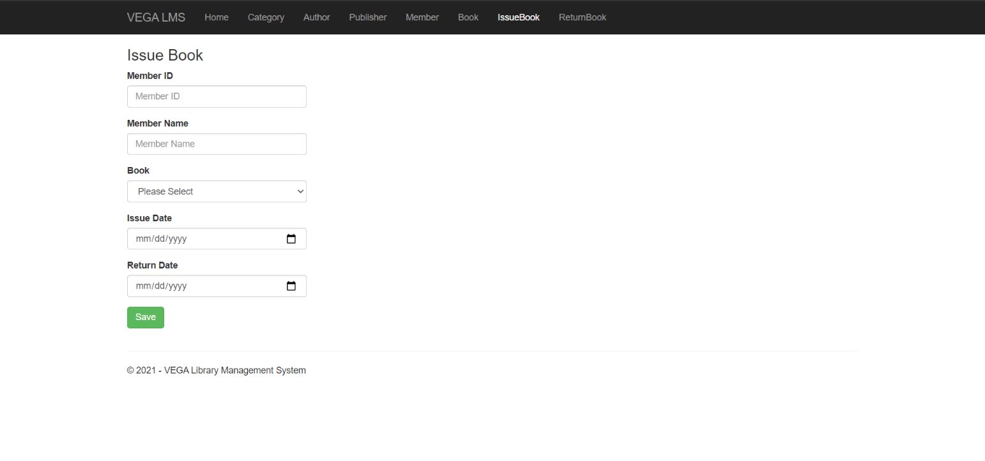

1. **Return Book**

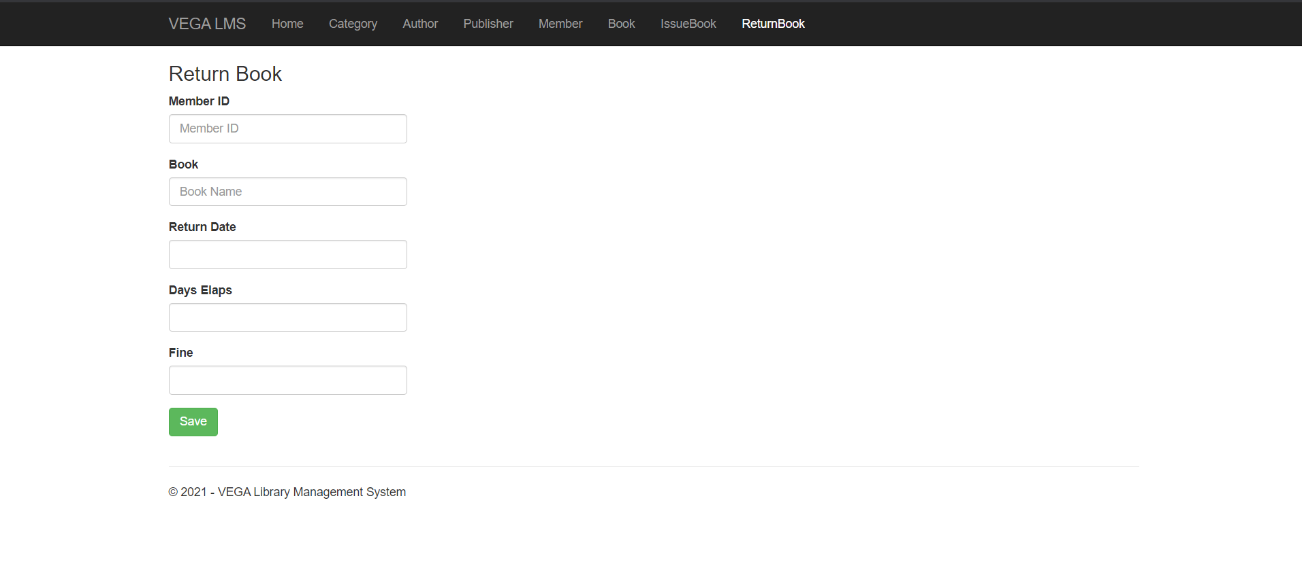

Limitations

* This system called “Library Management System” is platform dependent.
* Lack of secured data and security.

Conclusion

The project titled “Library Management System” developed under Windows environment using ASP.NET framework is an attempt to implement the proposed system. It was a great opportunity for us to learn about C# programming language. This whole project duration helped us to get the glimpse of practical usage of the knowledge that we learn in the real world.

The main objective of the project is to computerize the existing system where all the process was carried out manually. I had put my sincere effort to implement this project.

Full attempt is made to make the software bug free but as we know “to error is human”.

Bibliography

* C# 7.0 in a Nutshell, Joseph Albahari & Ben Albahari
* Visual C# 2012 How To Program, Paul Deitel & Harvey Deitel, Fifth Edition
* Visual C# Programming - https://www.c-sharpcorner.com/csharp-tutorials